**Problem Statement**

How might we help professional exhibition lovers in Shanghai to sift through various exhibitions so that they can easily choose the exhibitions that meet their specific requirements on theme/time/location, etc.?

**Plan**

**Result and analysis**

The task in this usability test is not exactly the same but similar to the task in previous test on the competitor’s website (<https://shanghai.douban.com/events/future-exhibition>). The most significant improvement made in this prototype (<https://www.figma.com/proto/H75MeJ4Z0XjFxnbPecDqdW/Exhibition_desktop?node-id=3%3A798&viewport=-442%2C108%2C0.15563780069351196&scaling=scale-down>) is to provide various sorting methods including open date, close date, district, price, and theme, in order to fulfil the specific requirements of professional exhibition lovers (Figure 1); while on Douban the filter of exhibition is only related to date (Figure 2).

Figure1



Figure2



It is observed that the time used to complete the task has been significantly reduced, as showed in following tables. Even though some hesitation, confusion and going back can still be observed, the test process of the 5 participants is relatively smooth.

Test1 (Competitor’s website)

|  |  |  |  |  |  |  |
| --- | --- | --- | --- | --- | --- | --- |
| Participant | A | B | C | D | E | Average |
| Time spent (second) | 218 | 313 | 166 | 143 (failed) | 175 | 203 |

Test2 (my prototype)

|  |  |  |  |  |  |  |
| --- | --- | --- | --- | --- | --- | --- |
| Participant | F | G | H | I | J | Average |
| Time spent (second) | 36 | 52 | 85 | 61 | 64 | 59.6 |

In addition to the improvement made, the test also reveals some issues of the website that need to be addressed in the future. Firstly, it is worth noticing that 4 out of the 5 participants started with the ‘按條件選擇’ button under the text‘隨便看看’(Figure 3). Only one of them used of the navigation ‘瀏覽最新展出’ on the top of the pages. This could implicate that the navigation option may not be clear and useful enough, so that the users won’t consider them as the starting point of the journey in the website in order to find the information they want. Besides, it may also because that the banner and huge text on the homepage are more attractive to the users, so that the participants tend to scroll down the page instead of using the navigation bar on the top.

Figure 3

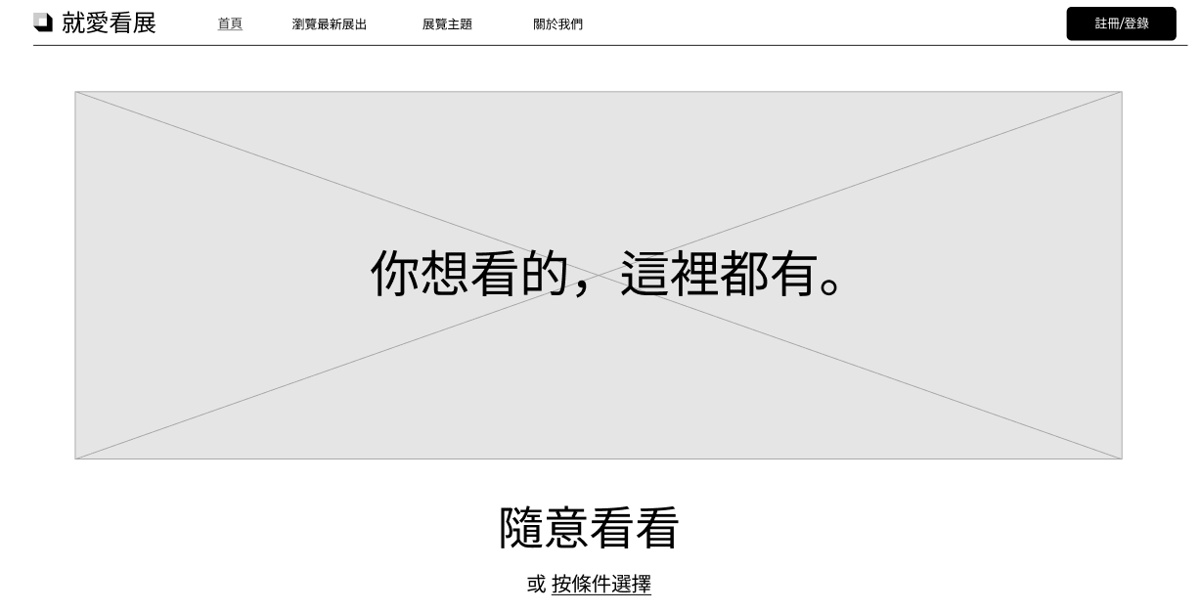

The second issue is reported by participant H. She said that the words on the sorting buttons are not clear enough (Figure 1), so that she mistake the text‘開始日期’for ‘結束日期’and spent much time trying to find out the answer on the wrong page (the most efficient way to compete the task is to sort by ‘結束日期’). Besides, she also suggested that the wording ‘由早到晚’and ‘由晚到早’ seems to be confusing. This remind me to figure out a more clear and explicit way to display the sorting methods and filters.

The third issue is reported by participant G and I. Both of them then used the ‘按照主題類型選擇’ button and try to find out the answer on the corresponding page (sort by theme; Figure 4). However, this page does not allow the users to sort the result again according to date, which means that the users would need to manually click on the title of each exhibition record in the row of ‘画展’and compare the close date by themselves. Noticing this issue, the participants then clicked on the ‘結束日期由早到晚’ button to complete the task. I believe this is the biggest issues of current prototype: the users can only use single sorting method at a time (for instance, they can choose to sort by either ‘主题’ or ‘结束时间’, but not both of them). In future version, I will try to enable the users to use multiple sorting methods/filters at the same time to fulfil more complicated requirements.

Figure 4

